CUSTOMER SURVEY REPORT

1. Tools and Transmissions Company
Date of visit: 24/03/26
Category: Small-scale Enterprise
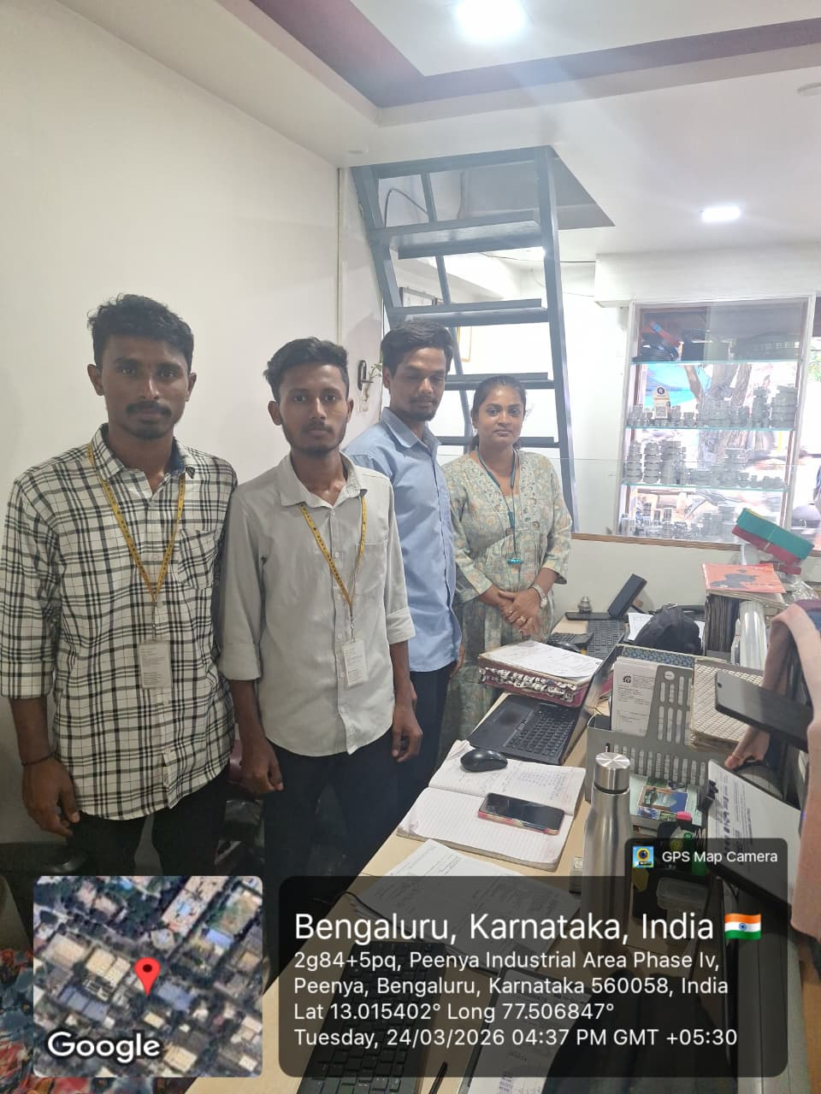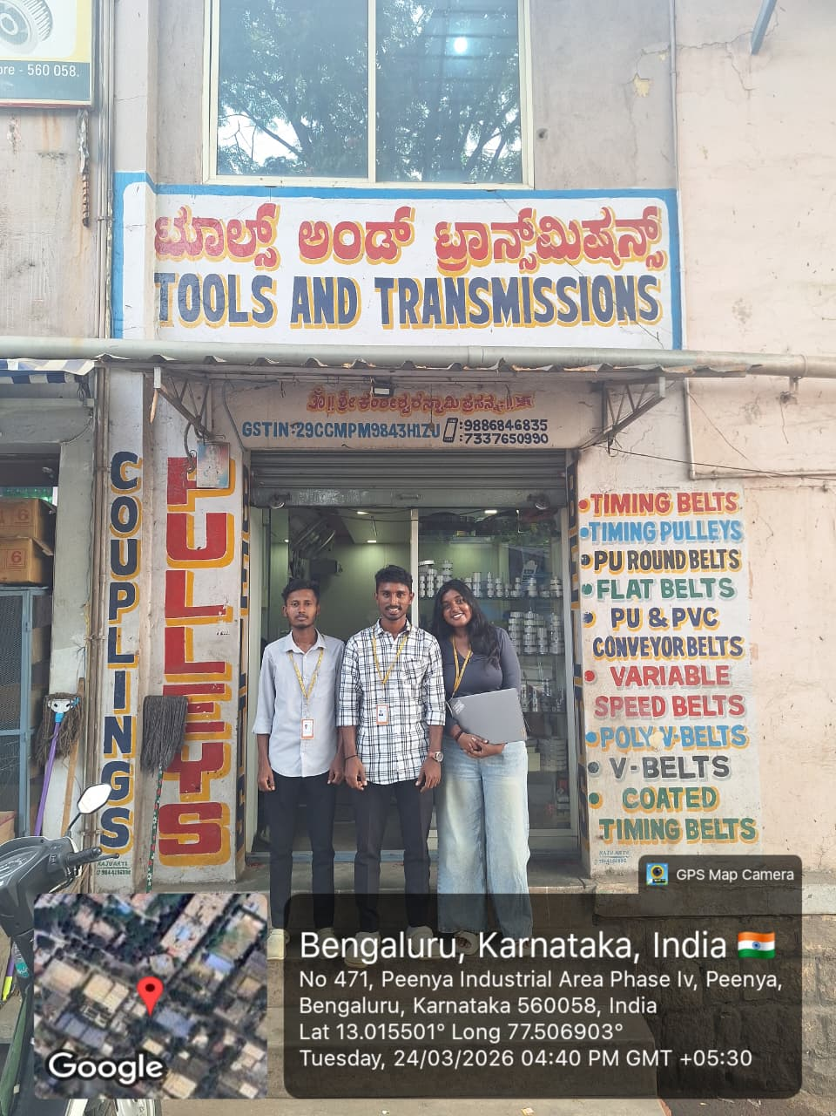

2. Plastic and Insulation Company
Date of visit: 24/03/26
Category: Medium-scale Enterprise
